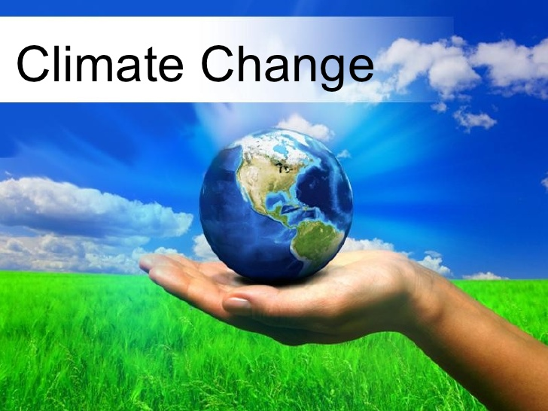

Climate Change: The science and the connections between your community and your classroom
Climate change is all over the news. What does it mean to you in the classroom? Are you comfortable explaining what it is and what is isn't? Join Holden Forests & Gardens, Lake Erie Nature & Science Center, Cuyahoga Soil & Water Conservation District and The Curriculum Department at the Bay Village Schools for a 3 day workshop on Climate Change. Learn the science behind climate change first hand from local scientists. Visit several locations to see how it is impacting our local communities; the beaches on Lake Erie, the Forests of Holden Arboretum and the urban landscape of Cleveland Botanical Garden. Find out how to incorporate these concepts into your classroom and see how it applies to the standards. Take part in hands on activities that bring the concepts to life in your classroom and leave with resources to help you weave it seamlessly into your curriculum. Become a Climate Change Fellow and take part in our planned ongoing educational lectures and support through the 2017-18 school year.
Date: July 25, 27 and Aug. 1
Time: 9 am-3 pm
Location: The Holden Arboretum, Lake Erie Nature and Science Center and Cleveland Botanical Garden
Cost: $150
Graduate Credit available for $100 – 1 SH from Lake Erie College

Register for all of this program at www.holdenarb.org or by calling 440.602.3833.
Contact Sharon Graper, Director of Academics at 440.602.3843 with any questions.

